**Web Marketing**

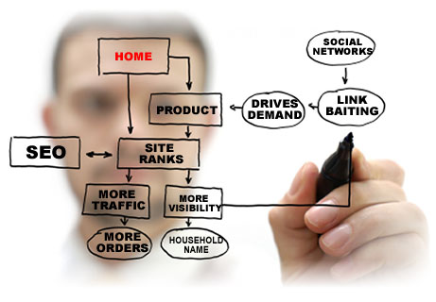

Online visibility has become vital for the success of any company in today’s competitive business environment. More and more companies are competing for the all-important virtual real estate that will get them found by their prospective customers online. For any company to make a mark in this age of competition, they have to employ web marketing strategies that will get them noticed and ensure long term success.

**Search Engine Optimization, SEO**  Quick Web design’s SEO services enable companies to realize their long term business goals and SEO marketing objectives.

**Search Engine Marketing, PPC**  We provides expert search engine marketing (SEM) and Pay Per Click (PPC) account management and consulting services in both a supportive and hands-on manner.

**Online Reputation Management**  With the exponential increase in online consumer awareness and the ease at which virtually anyone can write damaging reviews, being fully aware of your company and brand's online reputation is becoming increasingly important

**Local Map Optimization**

Studies have shown that 90% of people search online for local businesses. It is now more important than ever for local businesses to ensure that they are being found online locally through Local Map Optimization.